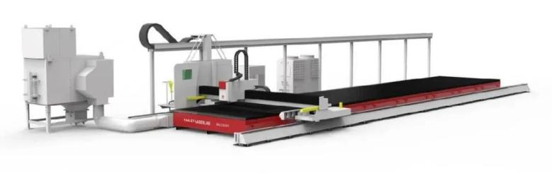
02 BF series Laser Bevel cutting machine

High precision: Bevel accuracy range is±0.5mm
High capacity: One-step shaping is done by cutting polygonal bevel
High quality: It’s noting difficult for bright cut
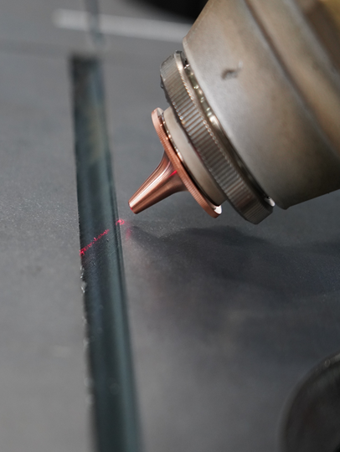

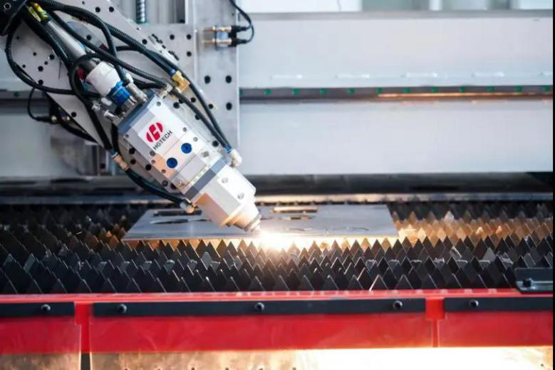
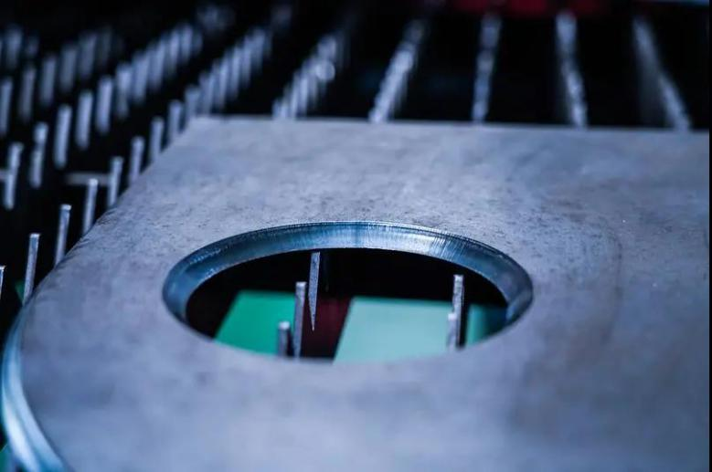
It is designed in elevated gantry structure and possess the characteristics of stable structure, high rigidity and high speed.
Integral welded structure bed: the beam is processed by multiple ageing treatments, and has high dynamic response. It is equipped with high-precision and high-efficiency structure system in transmission part, which has good rigidity and high precision, ensuring long-term high-precision operation of the equipment.
Independent R&D Fiber laser machine : Strong cutting and high efficiency, special laser cutting control system cooperatively developed with CNC system, which is a high-end high-tech fiber laser bevel cutting machine integrating laser cutting, precision machinery, CNC technology and other advanced technologies .

